**Class Activity: Alert Dialog**

1. How has your day been?

In this activity, we will be making use of AlertDialog and by clicking on the button, a basic alert dialog will pop up prompting users “How has your day been?”, which they can select either good or bad. Then the TextView in the main activity will update based on their response.

First, we will create a layout with a TextView that will be updated based on the user’s response from the alert dialog. In addition, have a button that will prompt the alert dialog to appear, named “Answer”.

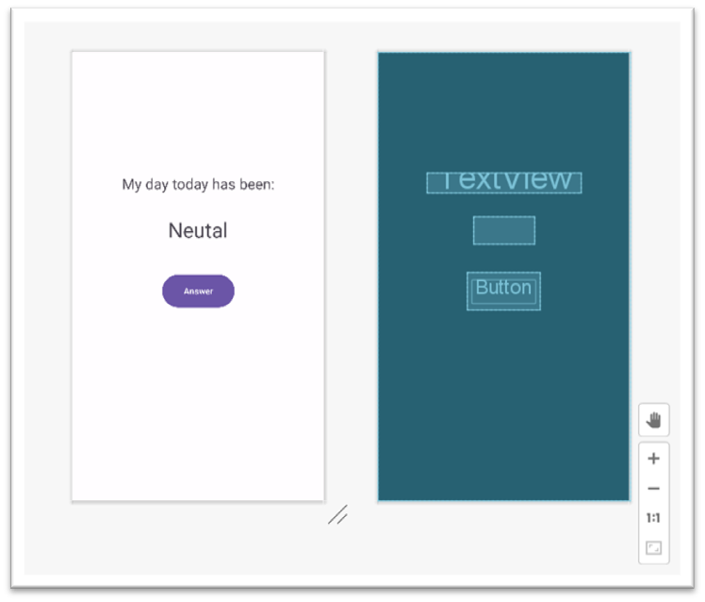

In the main activity, once the user clicks on the “Answer” button, an alert dialog will appear prompting the user how has their day been, either good or bad. Based on their response the “Neutral” TextView will be updated.

*Challenge: Change the TextView colour based on the user’s decision, green for good and red for bad.*

**Expected output:**

